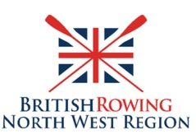

Signing up to the NWRRC mailing list conditions

The laws around how organisations can contact people are changed on 25th May 2018. These are known as the General Data Protection Regulations (GDPR).

By signing up to this communication link you are agreeing to the following conditions.

1.Your email address will be added to the NWRRC Distribution email list which is maintained by the Honorary Secretary of the North West Regional Rowing Council (NWRRC). Currently Mr J C Hill. The list can also be accessed by the Regional Technology Adviser, currently Mr P Jackson.

2. This list is used to communicate information about rowing matters in the Region including, but not limited to, Minutes of Executive Committee Meetings, Minutes of the AGM, information about forthcoming Events and about forthcoming Training Courses.

3. The only information held about you is your name and your email address.
None of this information will be publicised or passed on to other individuals or organisations.

4. You have the right to remove yourself from this list. By sending an email to NWRRCSecretary@gmail.com

In future, if you sign an Attendance list at NWRRC meetings e.g. the AGM, it will be assumed that you are agreeing to have your details added to the NWRRC Distribution Email List.

